Title: Amazon Brazil Sales & Customer Insights using SQL
Subtitle: A Data-Driven Analysis of Payments, Products, and Customer Trends
Prepared by: Pratik Garud
Date: 03/10/2025

Table And Schema -
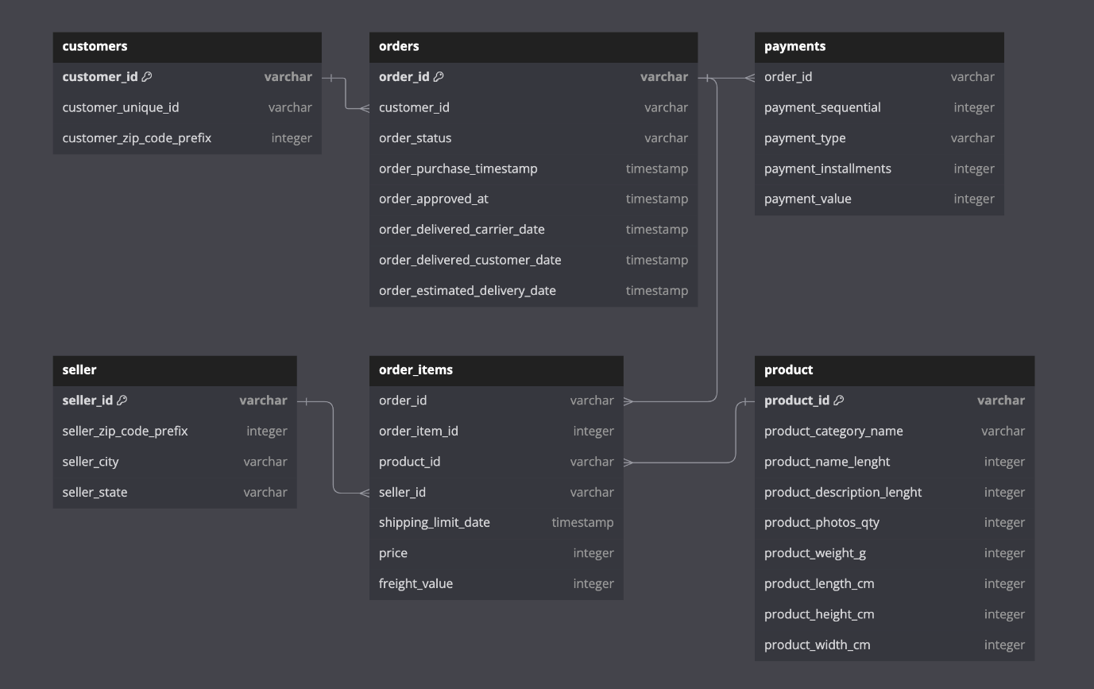

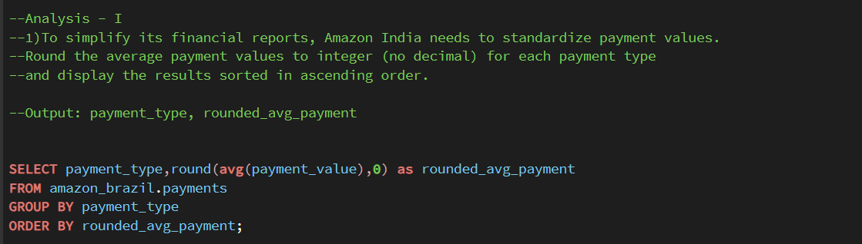

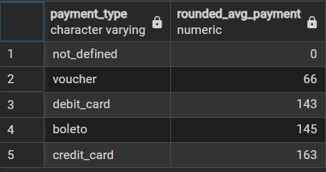

1) Rounded Average Payment Values
- Analysis: Payment values differ across methods, but rounding highlights general spending ranges per payment type. This simplifies reporting and comparisons.
- Recommendation: Use these standardized averages in dashboards and reporting to quickly benchmark transaction behavior by payment method.

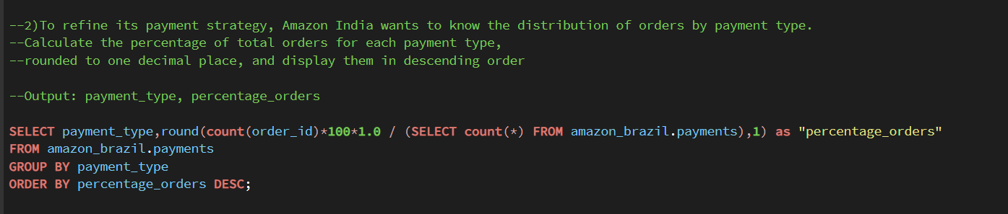

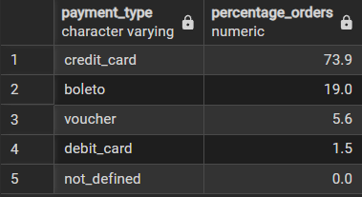
2) Distribution of Orders by Payment Type
- Analysis: Some payment methods dominate order volumes, while others contribute minimally. This shows customer preference trends.
- Recommendation: Prioritize support, offers, and reliability for high-usage payment methods while promoting adoption of less-used ones via discounts or incentives.

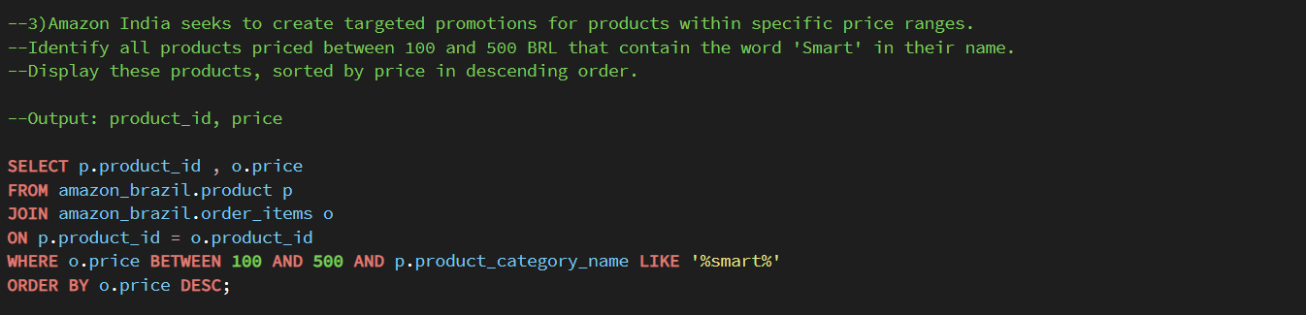

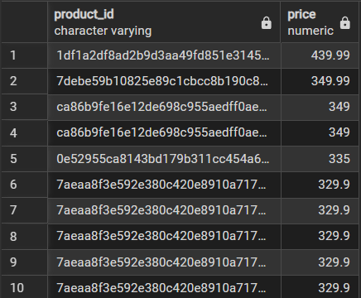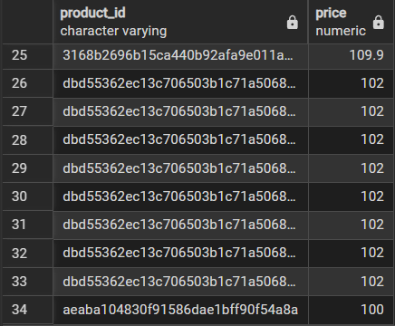

3) Products Priced 100–500 BRL Containing 'Smart'
- Analysis: Mid-range “Smart” products represent a competitive category where customer interest is strong.
- Recommendation: Position these products for targeted campaigns (bundles, promotions) since they are affordable yet high-demand.

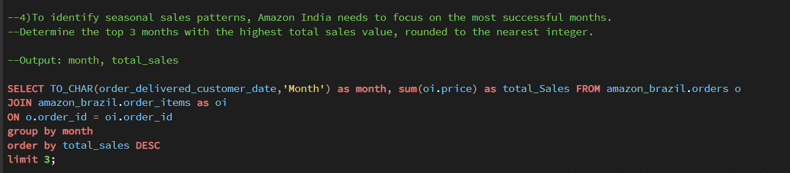

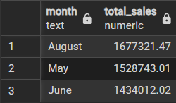

4) Top 3 Months with Highest Sales
- Analysis: Certain months show clear seasonal peaks, likely influenced by holidays, festivals, or sales events.
- Recommendation: Align inventory planning, ad spend, and promotions with these months to maximize returns during high-demand periods.

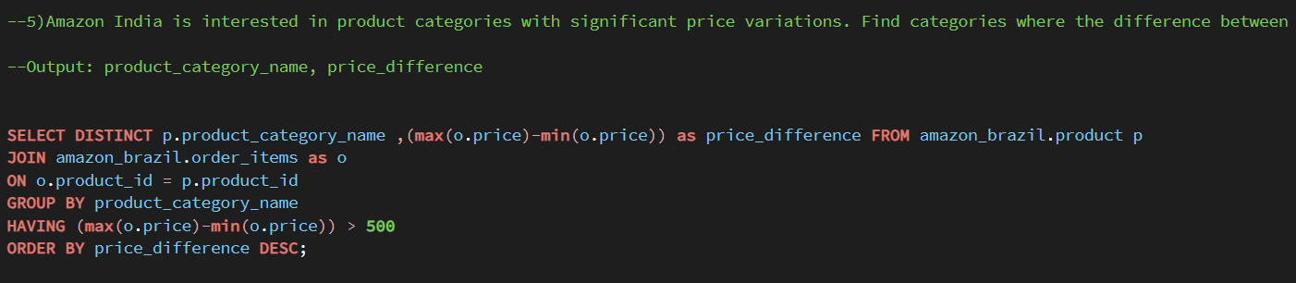

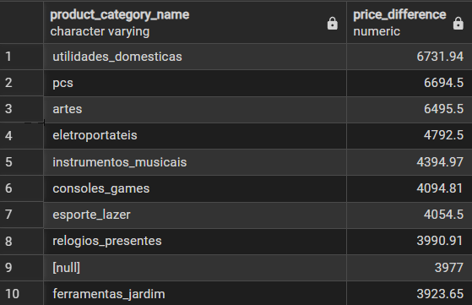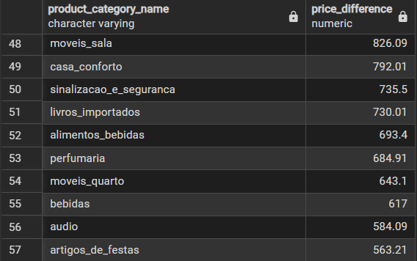

5) Categories with High Price Variations
- Analysis: Large price gaps within categories indicate diverse product ranges or inconsistent pricing strategies.
- Recommendation: Review pricing structures and consider tiered marketing (premium vs. budget segments) to cater to different customer groups.

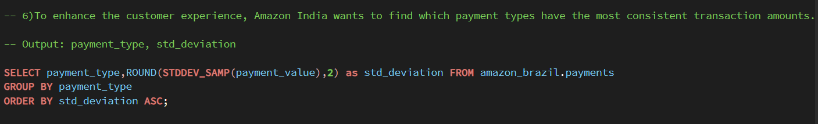

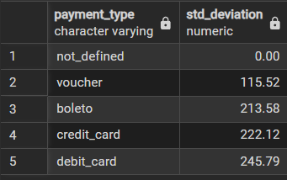
6) Payment Types with Least Variance in Amounts
- Analysis: Some payment methods have very stable transaction amounts, suggesting consistent usage patterns.
- Recommendation: Leverage these stable payment methods for subscriptions, EMI plans, or recurring payments where predictability is key.
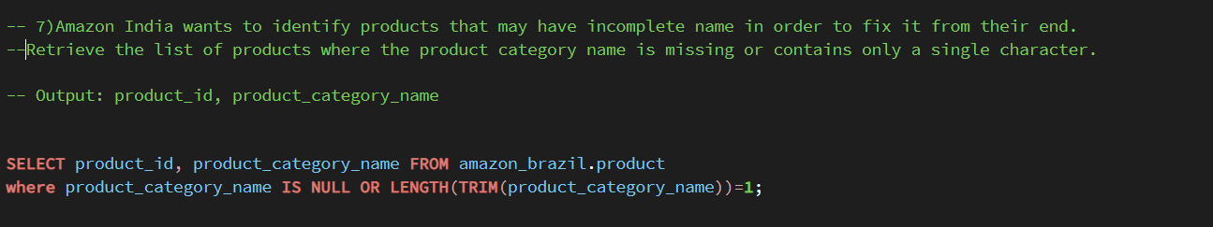

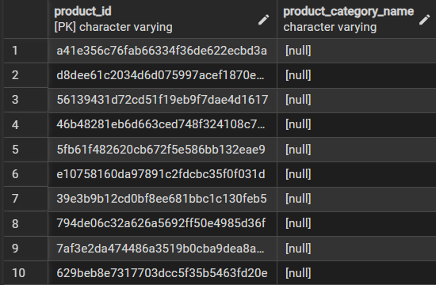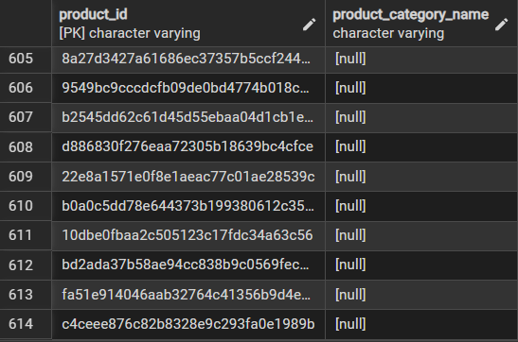

7) Products with Missing or Incomplete Names
- Analysis: Missing or incomplete product categories suggest data quality issues that can affect reporting and customer trust.
- Recommendation: Standardize and clean product data regularly to ensure accurate listings, better search visibility, and improved customer experience.

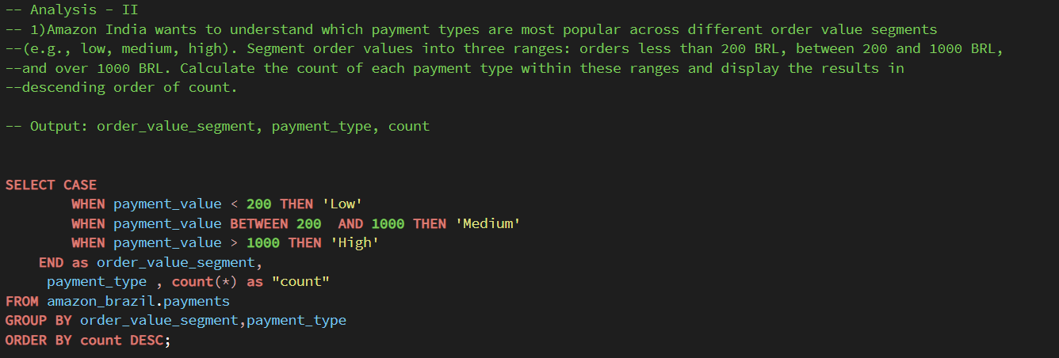

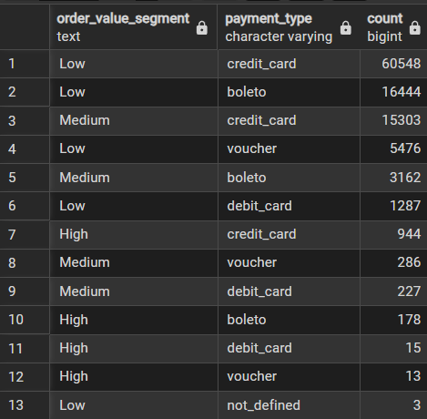

1) Payment Types by Order Value Segment
- Analysis: Payment preferences differ across low, medium, and high order values, with some methods dominating specific ranges.
- Recommendation: Align promotions and payment offers with segments—for example, push EMI or credit for high-value orders, and UPI/wallets for low-value ones.

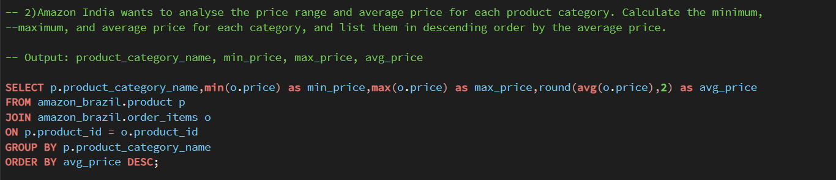

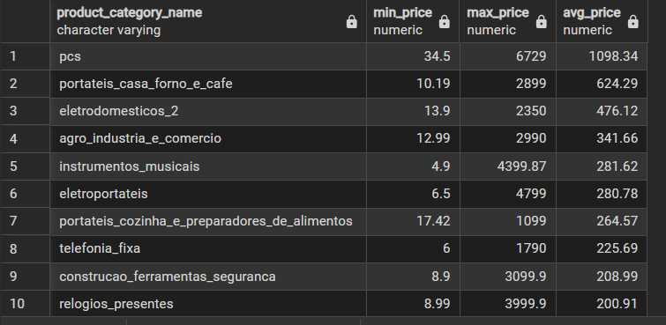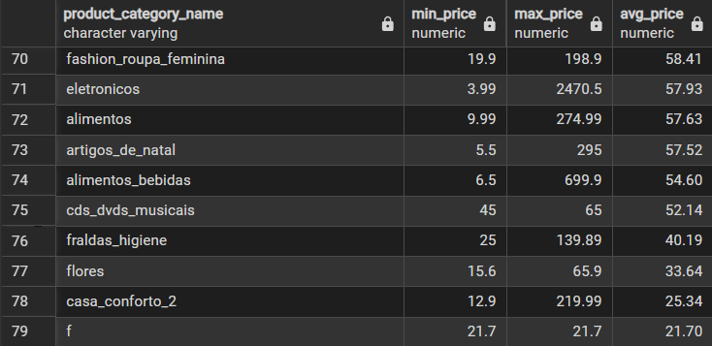

2) Price Range & Averages per Category
- Analysis: Categories vary widely in minimum, maximum, and average prices, showing distinct affordability bands.
- Recommendation: Position premium categories with higher marketing spend, while offering discounts on budget categories to drive volume.

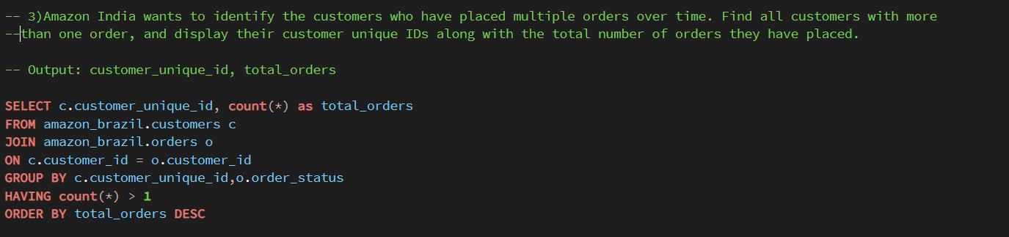

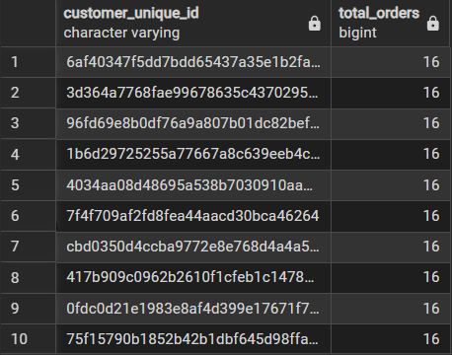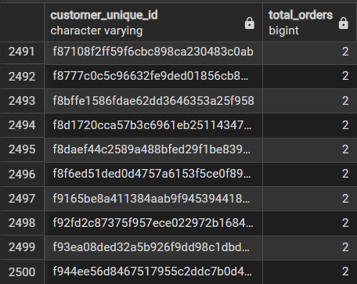

3) Customers with Multiple Orders
- Analysis: Identifies a segment of repeat buyers who contribute significantly to long-term sales.
- Recommendation: Launch loyalty perks and personalized campaigns for these customers to maximize retention.

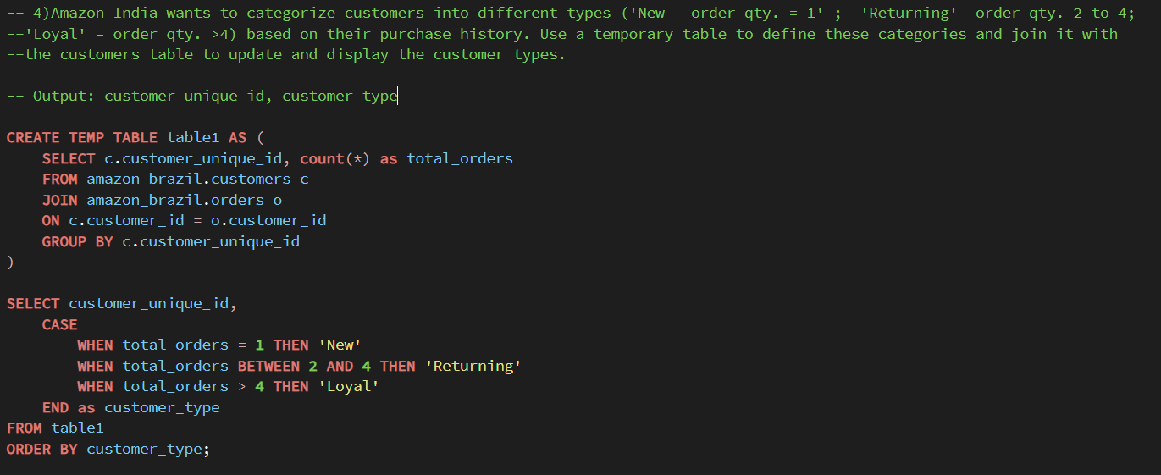

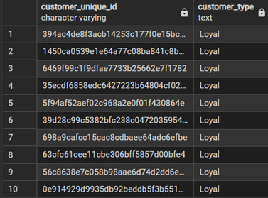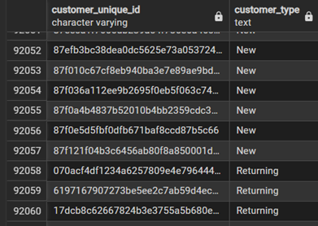

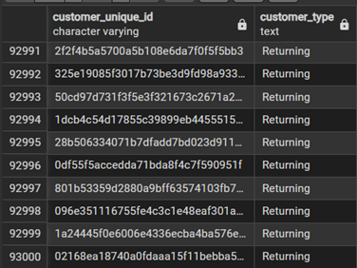

4) Customer Segmentation by Orders
- Analysis: Customers fall into clear groups—new, returning, and loyal—based on purchase history.
- Recommendation: Tailor engagement: welcome discounts for new, upselling for returning, and exclusive rewards for loyal customers.
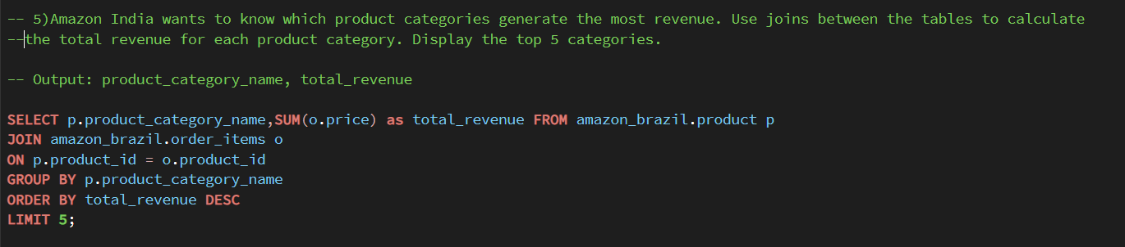

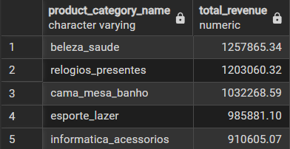

5) Top 5 Revenue-Generating Categories
- Analysis: A small set of product categories contributes disproportionately to revenue.
- Recommendation: Focus inventory, promotions, and partnerships on these top-performing categories to sustain growth.

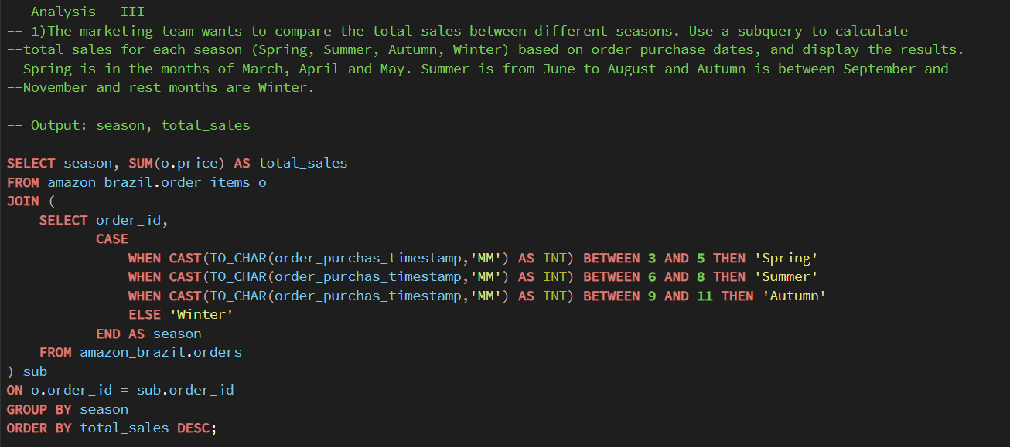
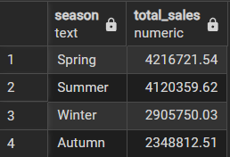

1) Seasonal Sales Comparison
- Analysis: Sales vary across seasons, with clear peaks in specific quarters tied to shopping events and festivals.
- Recommendation: Boost marketing budgets and stock during peak seasons, while using off-peak months for clearance sales.

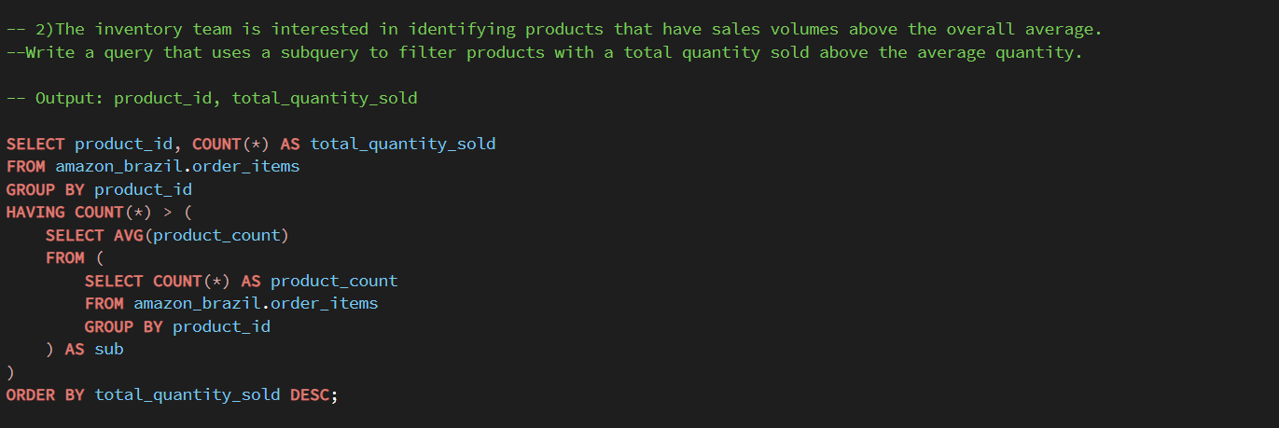

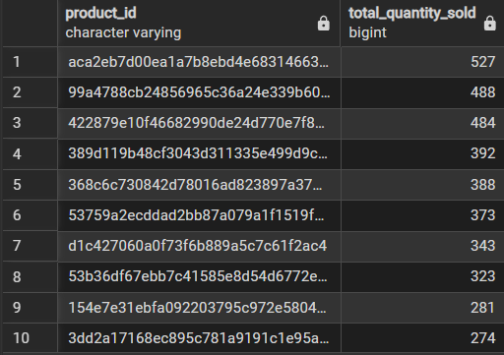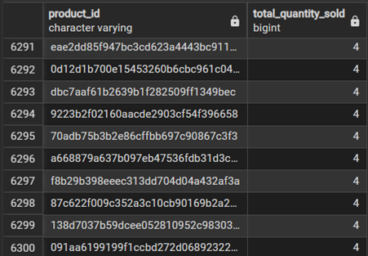

2) Products with Sales Above Average
- Analysis: Certain products consistently outperform the overall average in sales volume.
- Recommendation: Prioritize these high-demand products for promotions, bundle offers, and fast replenishment.

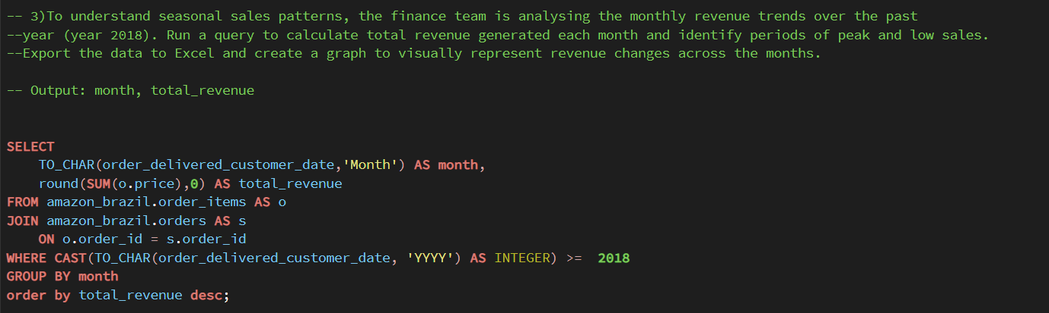

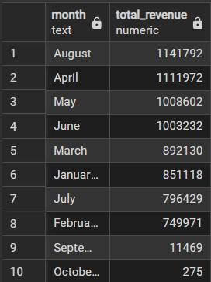

3) Monthly Revenue Trends (2018)
- Analysis: Revenue fluctuates month to month, with visible high and low periods indicating customer buying cycles.
- Recommendation: Use insights for budget planning and launch seasonal offers during low-revenue months to stabilize sales.

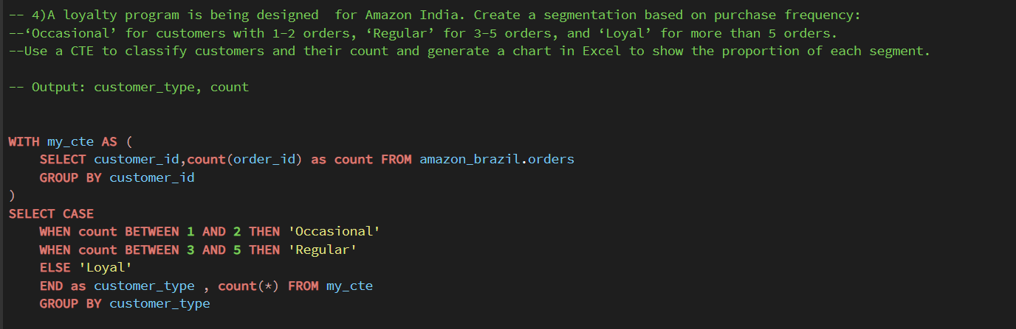

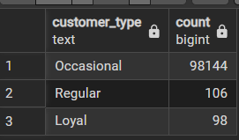

4) Customer Segmentation by Purchase Frequency (CTE)
- Analysis: Customers cluster into occasional, regular, and loyal groups, each with different value potential.
- Recommendation: Nurture occasional customers with reactivation offers, encourage regulars with bundles, and reward loyal customers with premium benefits.

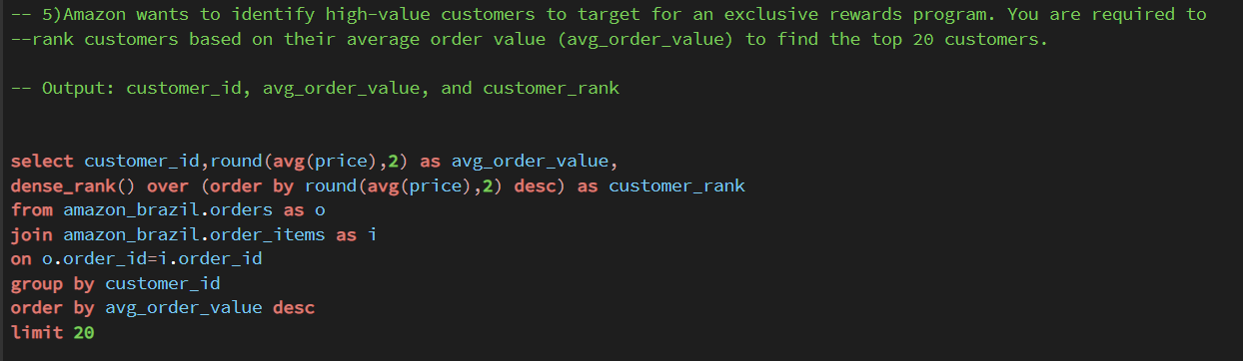

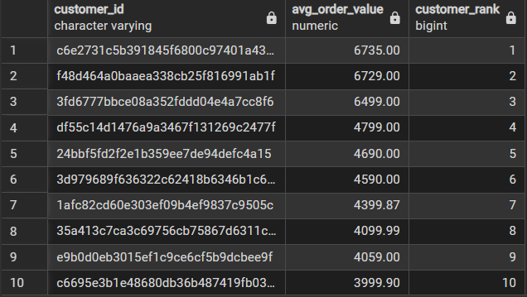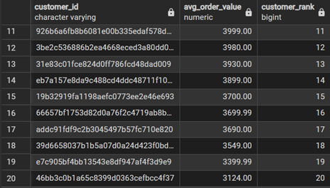

5) High-Value Customers (Top 20 Ranking)
- Analysis: A small set of customers drives high order values, making them key contributors to revenue.
- Recommendation: Build exclusive VIP programs for these customers with personalized deals to increase lifetime value.

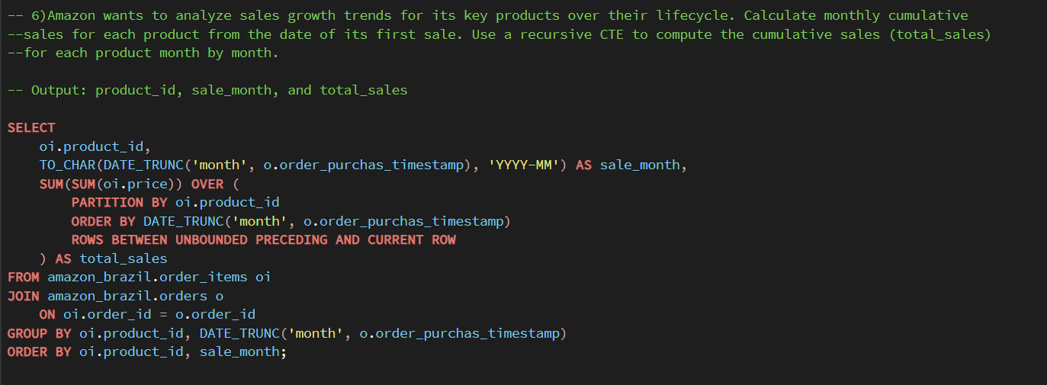

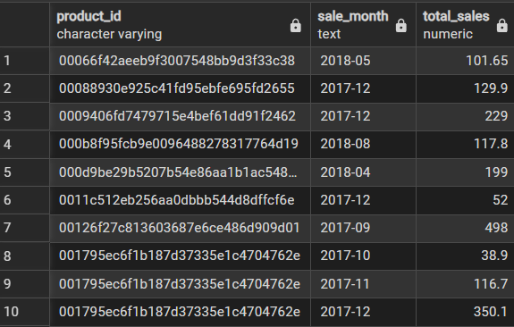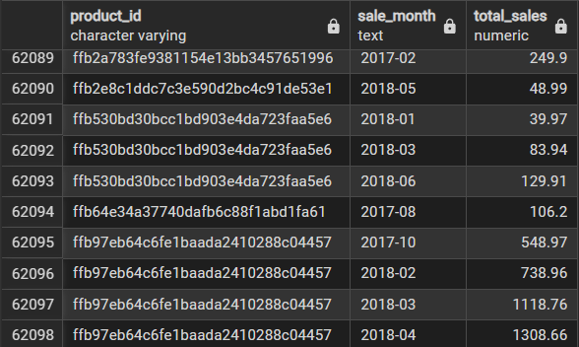

6) Product Lifecycle Cumulative Sales Analysis
- Analysis: Tracks cumulative monthly sales per product to show lifecycle growth.
- Recommendation: Focus marketing and inventory on consistently growing products and Use discounts or bundling to boost slow or declining products.

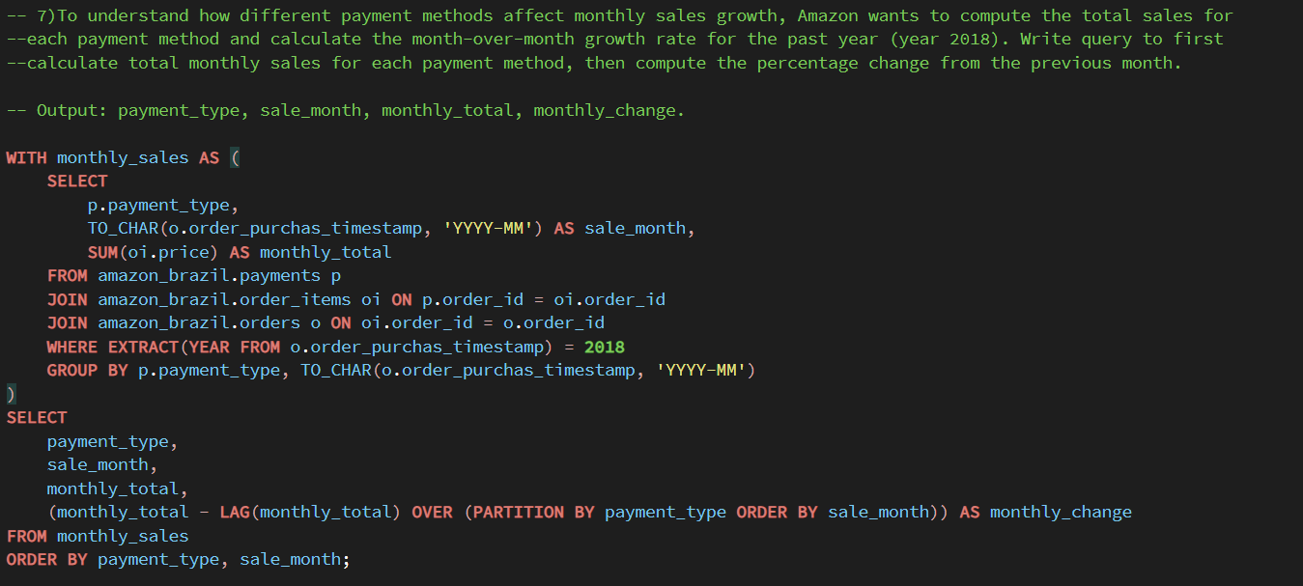
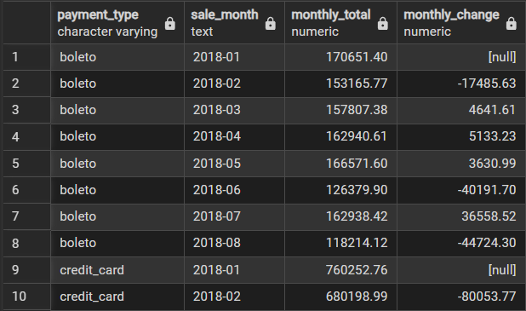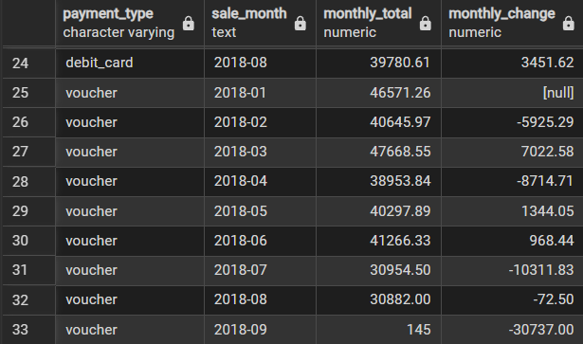

7) Payment Method Growth Analysis
- Analysis: Query highlights monthly sales and growth trends for each payment type in 2018.
- Recommendation: Include % change for deeper insight and ensure months are date-sorted for accurate trend analysis.

